|  |  |  |
| --- | --- | --- |
| Temasek Polytechnic | Description: ENG Logo | |
| Computer Programming for Problem Solving (ESE1006) – Project | | |
| Name: | | | Class: | |
| Tutor’s Comments: | | | Matric No: | |

**Project Specification**

1. **Problem Specification**
   1. Brief Description

To use the number of visitors to the different museums in Singapore for the period of 2013 to 2019 data in a python program and display 4 different menu options plus a Quit option.

Based on the user’s selection, the program will:

1. Display the visitor numbers of all museums in the year 2014.

2. For the 5-year timespan of 2015 to 2019,

a) the mean number of visitors of each museum.

b) the (mean) value and the name of the museum that has the lowest mean.

3. Of the user’s selected year, display the museums and their numbers of visitors, from the highest to the lowest number of visitors.

4. Plots:

a) Visitor numbers of ACM, TPM vs Year as line plots.

b) The lowest to highest number of visitors to NMS vs their sequence number as a bar chart.

Type of input data

A CSV file is used as the data source – museumvisitors_dataset.csv

Amount of input data

The dimension of the input data is 6x8 (6 rows and 8 columns).

**Problem Analysis:**

You are required to analyse at least 2 functionalities to pass (Analyze all 4 to get more marks)

The program starts by displaying the main menu, which allows the user to enter a choice of 4 different menu options plus a Quit option. The dataset is a CSV file and therefore pythons default csv package is used to read the data. Matplotlib and NumPy are used for plotting. All options are described in detail below.

First option is to display the visitor numbers of all museum in the year 2014. It can be done by iterating through the data source and finding the year given, in this case its 2014. This index is then passed on to each museum values and hence collecting all the visitors in the year 2014.

Second option is to display the mean value of the number of visitors of each museum from 2015 to 2019 and also to get the mean value and the name of the museum that has the lowest mean. The first sub-problem can be solved using the inbuilt mean() function. The mean() function in the python statistics library can be used to directly compute the average of a list. Next, print the least value from the list, which is the museum with least mean value of visitors.

Third option is to display the museums and their number of visitors in descending order of number of visitors for the user selected year. The index of the given year can be passed to the sorted data source and hence, returns the solution.

Finally, the fourth option is to create a:

1. Line plot
2. Bar chart

Matplotlib and NumPy can be used for plotting in python.

Problem Statement 1 (Function 1)

What are the input data and how are they acquired?

The input data is a CSV file (museumvisitors_dataset.csv) of size 6x8. Python’s default csv package is used to read the data. The csv.reader() function returns the data in a 2-dimensional matrix. This dataset is passed to the Main function.

What are the required output data?

The required output data is the number of visitors of all museums in the year 2014.

How do you get the required output(s)?

* Iterating through the dataset to find the index of the required year.
* Using that index to access the visitors value corresponding to each museum.

Problem Statement 2 (Function 2)

What are the input data and how they acquired?

The input data is a CSV file (museumvisitors_dataset.csv) of size 6x8. Python’s default csv package is used to read the data. The csv.reader() function returns the data in a 2-dimensional matrix. This dataset is passed to the Main function.

What are the required output data?

The required output data is:

* The mean number of visitors of each museum.
* The (mean) value and the name of the museum that has the lowest mean.

How do you get the required output(s)?

* Iterating through the dataset and calculating the mean number of visitors of each museum.
* Finding the least value from that list.

Problem Statement 3 (Function 3)

What are the input data and how are they acquired?

The input data is a CSV file (museumvisitors_dataset.csv) of size 6x8. Python’s default csv package is used to read the data. The csv.reader() function returns the data in a 2-dimensional matrix. This dataset is passed to the Main function.

A user chosen year is also passed as a parameter.

What are the required output data?

The required output is to display the values of all the museums and their respective number of visitors, from the highest to the lowest number of visitors for the given year.

How do you get the required output(s)?

* Iterating through the dataset
* Find the index of the given year
* Using the index to access all the values for that particular year.
* Python sort function to sort in descending order.

Problem Statement 4 (Function 4)

What are the input data and how are they acquired?

The input data is a CSV file (museumvisitors_dataset.csv) of size 6x8. Python’s default csv package is used to read the data. The csv.reader() function returns the data in a 2-dimensional matrix. This dataset is passed to the Main function.

* Visitor numbers of Asian Civilizations Museum, The Peranakan Museum and Year as python lists.
* National Museum of Singapore and sequence number as python lists.

What are the required output data?

The required output data is:

* A line plot with x-axis as Year and y-axis as Visitors of ACM and TPM.
* A bar chart with the lowest to highest number of visitors to NMS vs their sequence number.

How do you get the required output(s)?

* First, required variables are initialized and declared with its respective values.
* For the line plot, Matplotlib.plot() function can be used.
* For the bar chart, Matplotlib.bar() function can be used.

1. **Problem Design**

Flowchart of *main* function

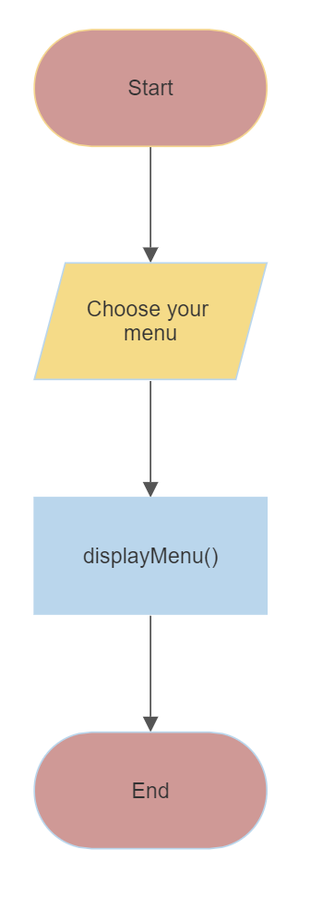

Flowchart of *displayMenu* function

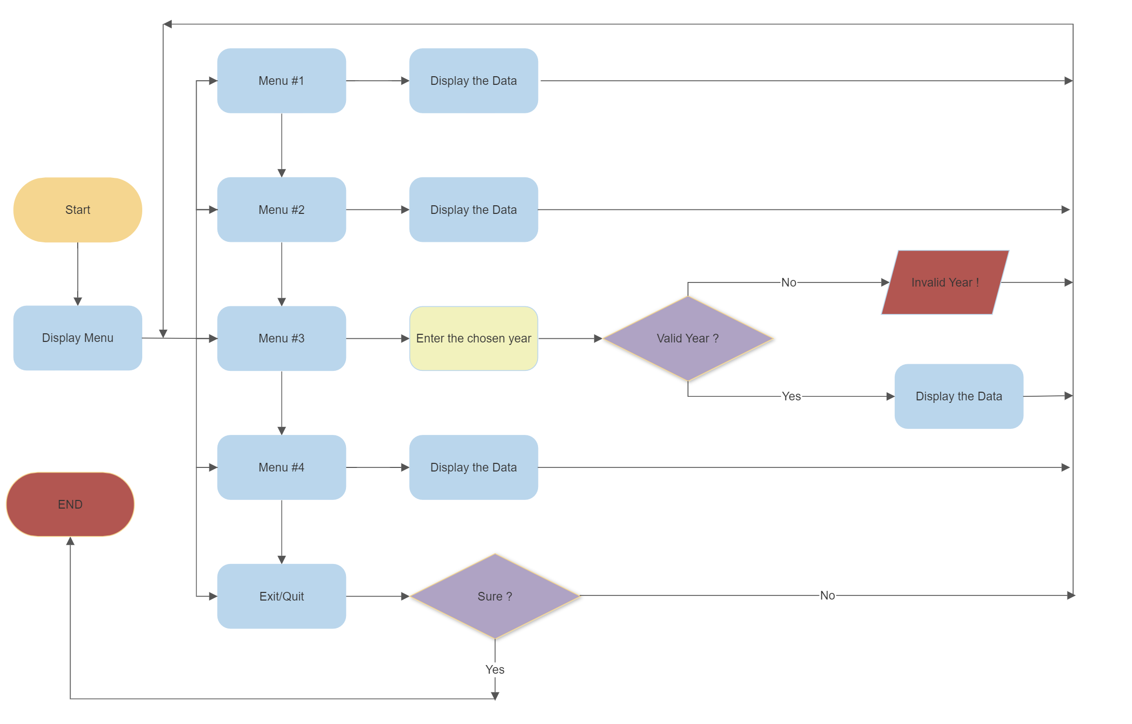

1. **Flow Charts for the 4 functions to be added here. Add as many pages as needed**

